**The UI, User and testing**

**How will the user connect:**

* The user will first sign up and log in to their account

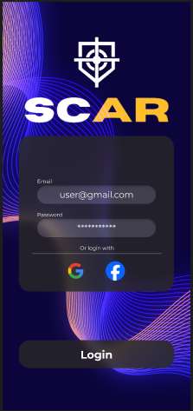

* If they are going to play a game and want their scope to track their statistics, they will first need to click on the start game button, once clicked the user will be greeted with an option to link their stats to a weapon and finally a configuration screen where the user can do a last second adjustment

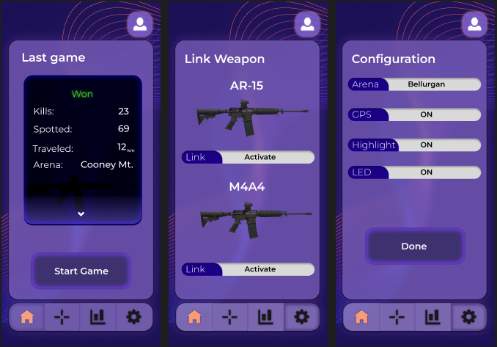

**Available Data:**

* The user will be able to see statistics such as the kills they did and distance travelled during a match, to view their statistics they will have to interact with the statistics functionality, triggered by a button located at the bottom of the screen

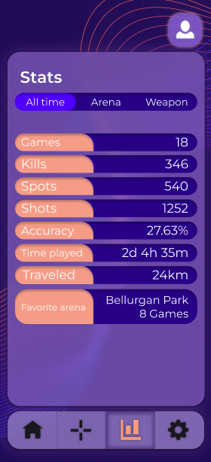

* The user’s statistics will be converted into points where other users will be able to see them by accessing the leaderboard

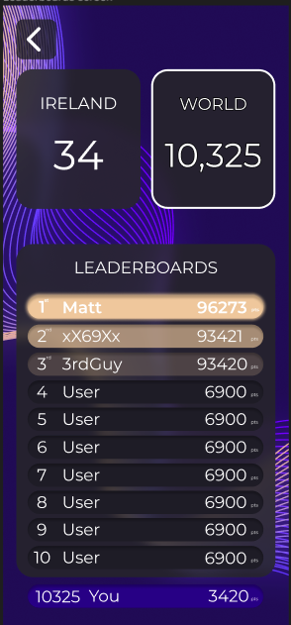 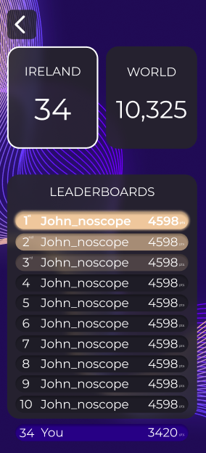

* The data showed will be different according to the user choice, so if the user only choose the regional ranking only the users in the same regions will be shown, and if they choose the world rankings every user point will be show on the leaderboard
* The application will keep track of the crosshair specification that the user made, user will be able to access this data and modify it by using the crosshair editor

